Position of road closure
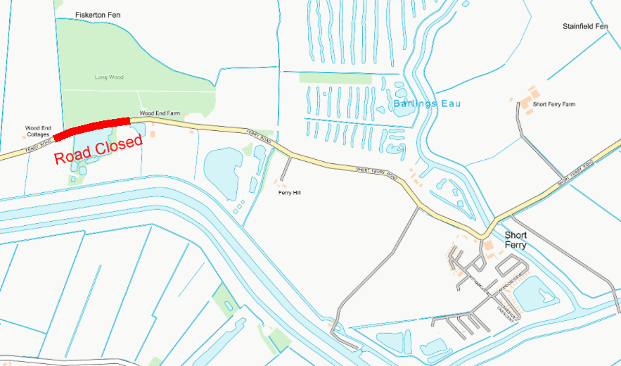

Diversion Route
Travel east along ferry Road, Fiskerton up to junction of B1202, turn left towards Wragby. Turn left at Wragby onto A158. Travel west towards Lincoln, turn left on to Kennel Lane, Reepham. Carry on to junction, turn left to High Street, Reepham. Travel on to Station Road, Reepham. Bear right on to Fiskerton Road, Reepham. Carry on to Reepham Road, Fiskerton. Carry on along Chapel Road, Fiskerton. Turn left on to Ferry Road, Fiskerton. Reverse route for reverse journey.

